***ACTIVITY Nº 01***

5 YEARS

Miss Karina Cosio

**ENGLISH FOR KIDS**

***“HELLO”***



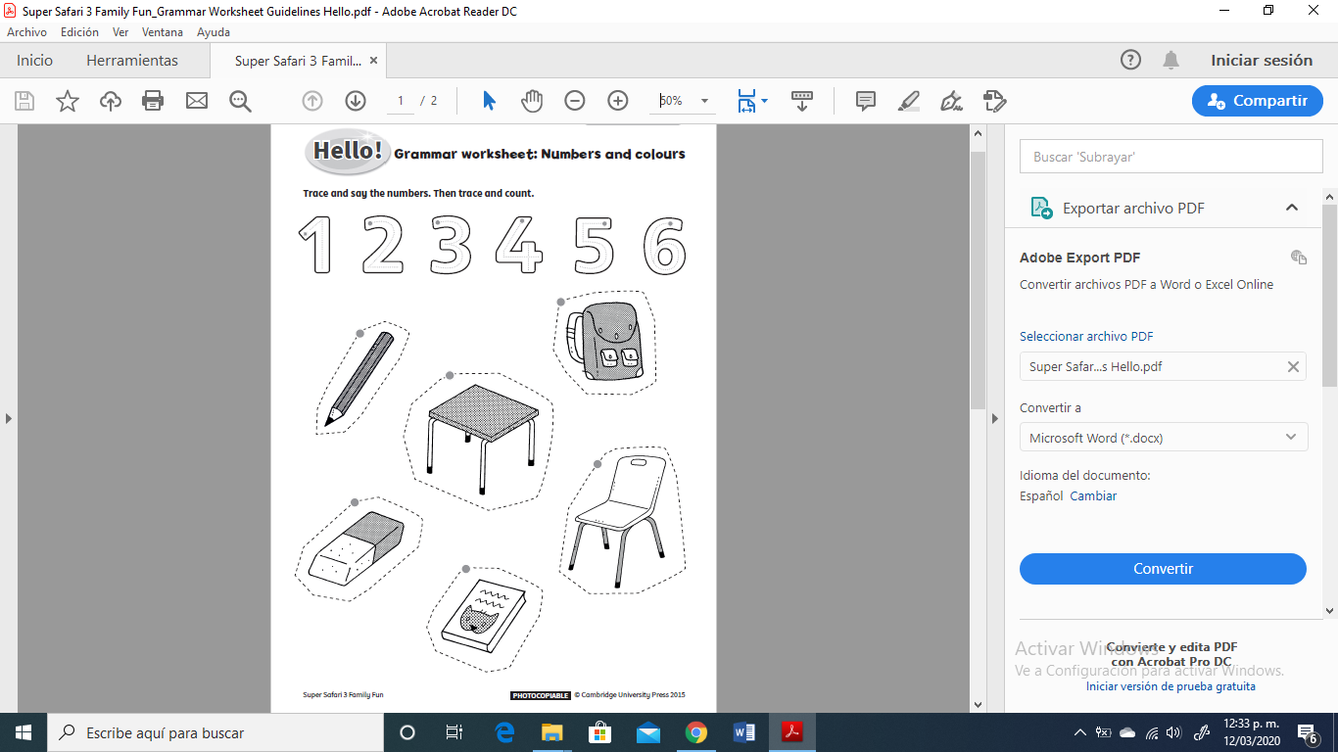

**INSTRUCTIONS:** *Point to the numbers and practise them with your child. Give crayons. Point to each classroom item in the worksheet and encourage your child to name them with you. Ask about the colour of each one. He/She colours the items, each in a different colour. The child then traces the dotted numbers on the second half of the worksheet.*

**INDICACIONES:** Señalar los números y practicarlos con su pequeño (a). Brindar crayolar y señalar cada útil escolar y motivar a nombrarlos y luego a colorearlos, cada uno de diferente color. Finalmente trazar los números y objetos.

DATE: Thursday 12th of march, 2020

ACHIEVEMENT INDICATOR: Identify numbers and school objects. /Identificar números y útiles escolares.