PREPOSITIONS OF PLACE
Worksheet N° 4

English Competence  WRITTEN PRODUCTION | Grade  4° L - V | Content  Vocabulary related to the prepositions of place | Subject  English
Academic Contextualized performance | Identify the prepositions of place  Use the prepositions of place in a sentence
Webgraphy  Bibliography | Academic stars 4- Macmillan – ISL COLECTIVE
Teacher | Corayma Caceda Gonzalez

Surname and Name:

…………………………………………………………………………………

Instructions:

- Dear Student, here you have a list of videos about prepositions of place. Learn it and practice at home.
https://www.youtube.com/watch?v=w7ygOVh6T-Y
https://www.youtube.com/watch?v=caSZRnTRd40
https://www.youtube.com/watch?v=cpHTgi5ZKjY

- Practice the correct pronunciation using the video.
- Look at the picture and practice.
- Send it to me: ccaceda@iepmercedarias.edu.pe, DEADLINE 8TH APRIL.

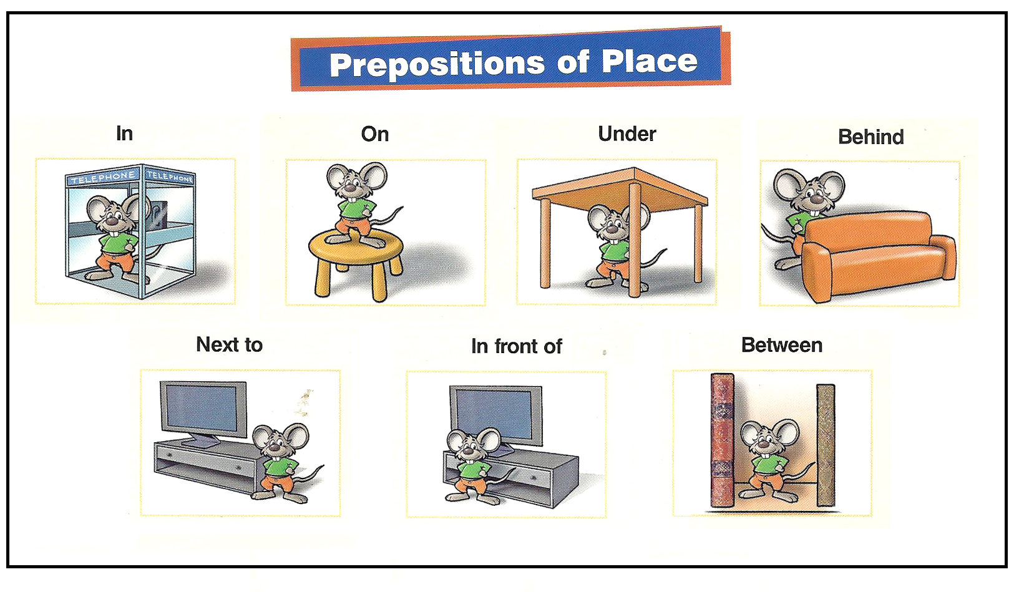

- Draw the bear according to the preposition.

Where’s the bear?
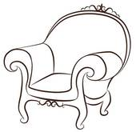
The bear is on the chair.
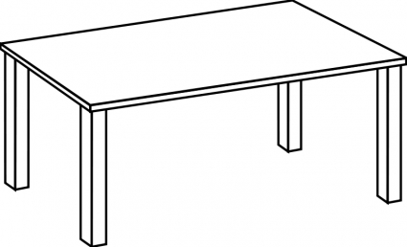

The bear is under the table.

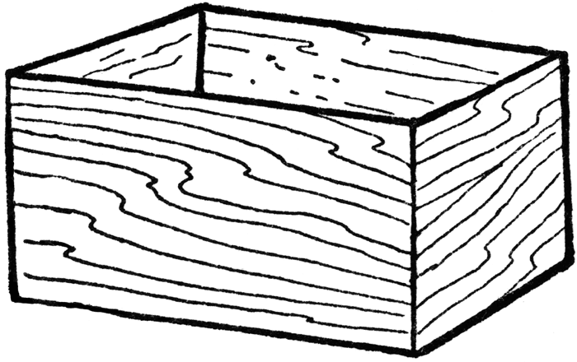
The bear is in the box.

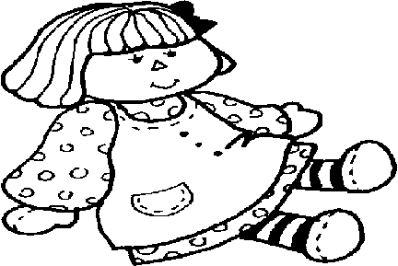

The bear is in front of the doll.

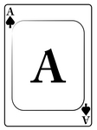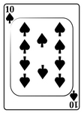

The bear is between the cards.

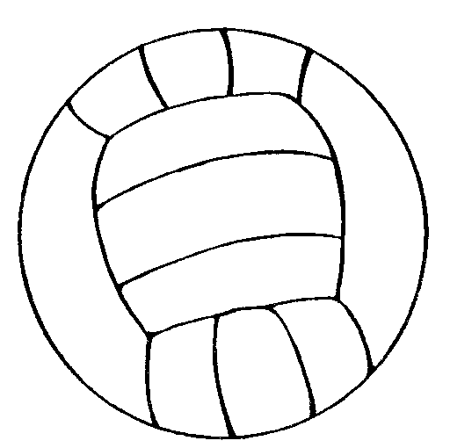

The bear is next to the ball.

- Write the correct preposition of place according to the picture.
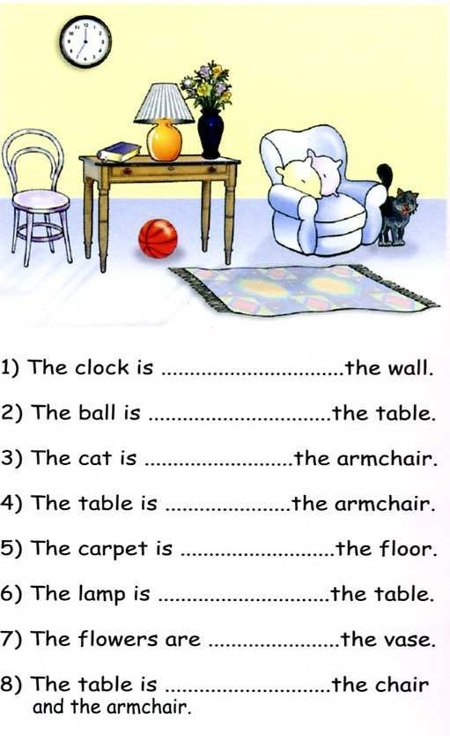

SELF-ASSESSMENT
My name is on the paper.
I watched the video
I read the spelling chant.
I completed the sentences
I draw the bear

