***ACTIVITY Nº 05***

4 YEARS

Miss Karina Cosio

**ENGLISH FOR KIDS**

***“MY SCHOOL”***

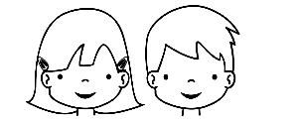

DATE: Friday 18 th of march 2020

ACHIEVEMENT INDICATOR: Identify Classroom objects. /Identificar útiles del aula.

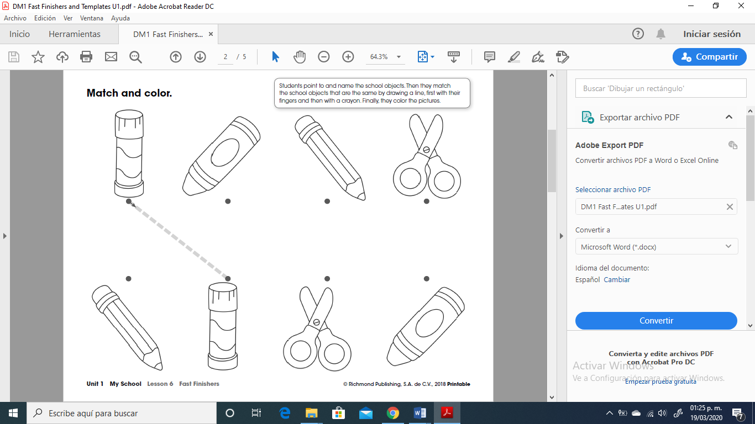

**INSTRUCTIONS:** Students point to and name the school objects. Then they match the school objects that are the same by drawing a line, first with their

fingers and then with a crayon. Finally, they color the pictures.

**INDICACIONES**

Mostrar el vocabulario y repasar (PPT). Luego señalar y nombrar cada objeto. Su pequeño (a) tiene que unir parejas de útiles escolares. Primero con su dedo mágico “magic finger” y después con su crayola. Finalmente colorear.