Student’s name:
Language skills:  Speak in English as a second language.  Specific skill:  To describe the rooms in their houses using there is – there are and prepositions of place. | 1st. Basic Liberty - Truth | Content:  There is – There are / Prepositions of place | Subject: English
TEACHER: Jakeline Huamaní
BIBLIOGRAPHY: Gateway A2 teacher’s resource – Macmillan
WEBSITE: Macmillan education everywhere
THERE IS – THERE ARE / PREPOSITIONS OF PLACE
Instructions:
- Read the grammar bank
- Connect in ZOOM virtual class
- Unit 2 – English book.
- Record an audio describing a room in your house.
- Send the answer to the e – mail jhuamani@iepmercedarias.edu.pe

Activity 1: Read the grammar bank about there is there are.
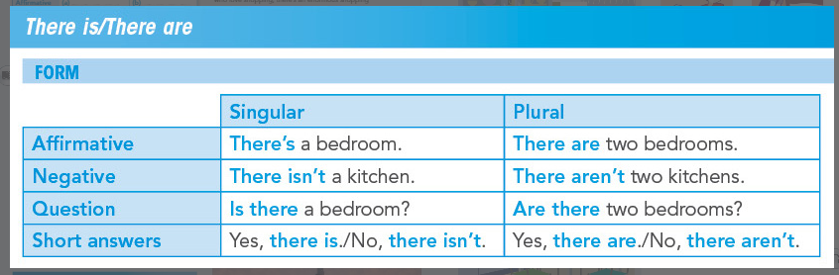

Activity 1: Complete the table.
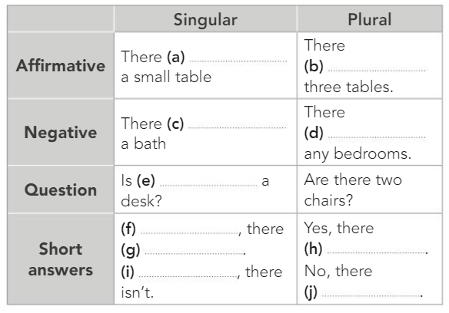

Activity 3: Check the prepositions of place.

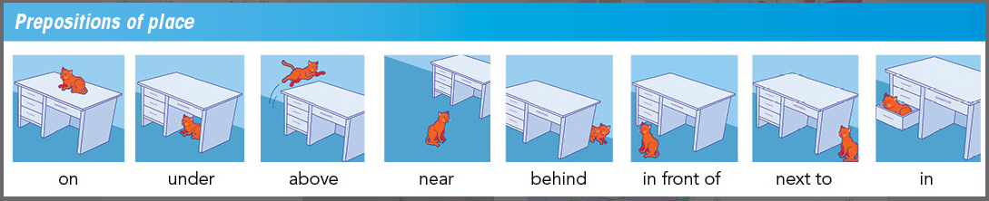

Activity 4: Record an audio describing one of the rooms in your house using there is – there are and preposition of place. Attached the file of the audio in your email.

Self - Assessment

Your name is on the worksheet. | YES | NO
I learnt the grammar rules | YES | NO
I can consistently do my own correction and record myself | YES | NO
I check and do on my own pace | YES | NO

Evaluation Rubric for Oral Production (oral participation/presentation, debates)

Areas of Assessment | A | B | C | MARKS
Ideas &  Organization | - Presents and organized ideas / opinions in an original manner | - Presents and organized ideas / opinions in a consistent manner | - Ideas and lack of organization / opinions are vague or unclear.
Word Choice | - Sophisticated use of nouns and verbs in the description | - Nouns and verbs used in the description | - Little or no use of nouns and verbs
Sentence Structure  And grammar | - Sentence structure enhances meaning;  - Use the grammar required  - Few (if any) any errors | - Sentence structure is evident; sentences mostly flow  - Use the grammar sometime  - Few errors | - No sense of sentence structure or flow  - Don’t use of the grammar  - Numerous errors
Voice projection | - Loud voice can be clearly understood | - Voice can be understood but heard. | - Deficient voice projection can’t be understood or heard
Pronunciation | - Good pronunciation and fluence speaking, few or less mispronouncing | - Pronunciation with some mispronouncing and not fluence speaking | - Uses Spanish and English.  - Many mistakes in pronunciation and lack of fluency.

