Student’s name:
Language skills:  Write in English as a second language.  Specific skill:  To identify the use of the present continuous and present simple in home activites. | 1st. Basic Liberty - Truth | Content:  Present Continuous and Present Simple | Subject: English
TEACHER: Jakeline Huamaní
BIBLIOGRAPHY: Gateway A2 teacher’s resource – Macmillan
WEBSITE: Macmillan education everywhere
Present Continuous and Present Simple

Instructions:
- Read the grammar bank about present continuous
- Connect in ZOOM virtual class
- Unit 2 – English book.
- Send the answer to the e – mail jhuamani@iepmercedarias.edu.pe

Activity 1: Read the grammar bank about present continuous.

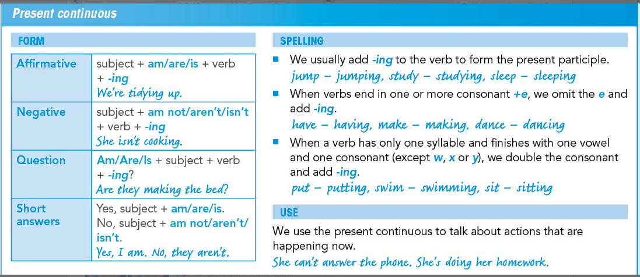

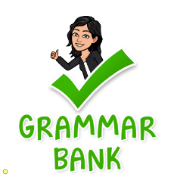

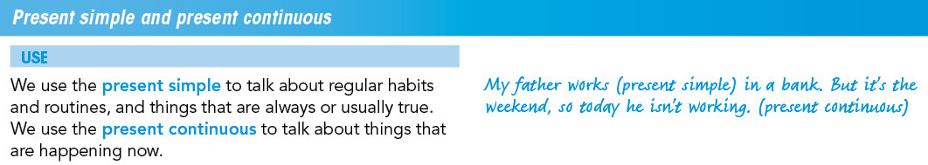

Activity 2: Look at the spelling rules for the -Ing. Form of the verb and complete the chart with the correct form of the verbs.

Chat – Dance – Do – Eat – Have – Put – Sit – Study – Take – tidy - Wash

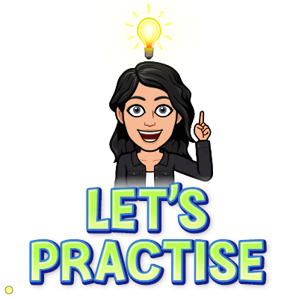
Most of verbs:  Add -Ing | Verbs ending in consonant + e: Take away e and add -ing. | Verbs ending in one vowel + one consonant, double consonant and add – ing.
Play – playing  Cook - Cooking | Write – writing  Make - Making | Run – running  Swim – Swimming

Activity 3: Check the prepositions of place.
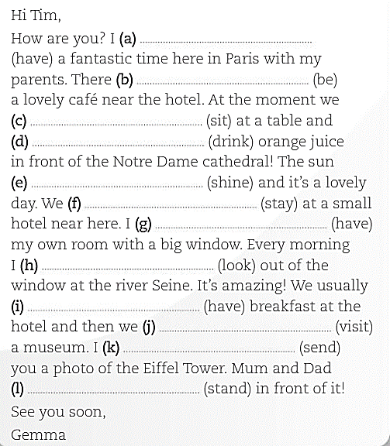

Self - Assessment

Your name is on the worksheet. | YES | NO
I learnt the grammar rules | YES | NO
I identify the verbs in present form | YES | NO
I can consistently do my own correction. | YES | NO
I check and do on my own pace | YES | NO

