READING COMPREHENSION WORKSHEET N.7

Student’s name: Date:
COMPETENCE: READING COMPREHENSION  CONTEXTUALIZED ACADEMIC PERFORMANCE: obtain and analyse information from the text | 3RD SECONDARY INTERMEDIATE | Content:  Reading comprehension  “UNIT 2” | Subject: ENGLISH
TEACHER: Jenny Roxana Bravo Marroquin
BIBLIOGRAPHY: OPTIMISE b2 second edition - macmillan
INSTRUCTIONS:

Dear students,

Remember to have your complete English materials during virtual classes. Besides, it is important to follow the rules the teacher mentioned about respect and the appropriate scenario to be participant during the virtual classes, In addition, look up the new words from the text below and write them on your English notebook including the definition and example that can help you remind the words in context

Worksheet:

Before reading:
- Look at the photo and read the title of the text
- What do you think the text is about?

During Reading
- Skim the text and underline the words you may have problems of misunderstandings or doubts
- Scan the text analysing everything in detail
- Write the new words including the definition and examples on your English notebook.

After Reading:
- Exercises about reading comprehension will be shown, developed and analysed during virtual classes.
- Give responds giving explanations and participate in order to consider your participation mark
- Your examples which are part of your development are essential evidence you will show when the teacher ask for it during virtual classes.

Please take a photo to the examples developed as part of your evidence process and send it to my institutional email: rbravo@iepmercedarias.edu.pe

Reading 1

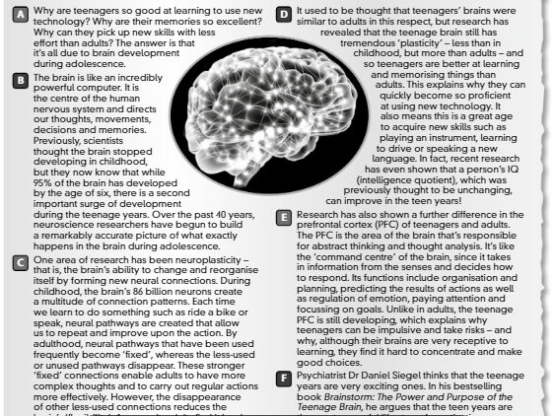

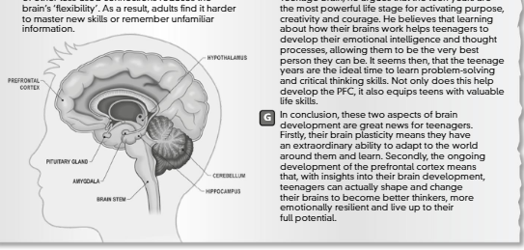

Reading 2: student book page 12

