What’s this?
Worksheet N°8
English Competence  Text production  Oral production | Grade  1° L - V | Content  What’s this?  A or AN | Subject  English
Academic Contextualized performance | Text production: Write answers using the grammar structure correctly.  Oral production: Interact with a partner asking and answering questions to identify objects in a short dialogue.
Webgraphy  Bibliography | https://www.youtube.com/watch?v=ZbZSe6N_BXs  https://www.youtube.com/watch?v=mTisVqSrfF0  https://www.youtube.com/watch?v=B8MbH5Wwf5I  Academy stars 1 - Teacher’s resource book – Macmillan
Teacher | Mariluz Bujaico Zarate

Surname and Name: _______________________________________ Grade: 1st - ___________
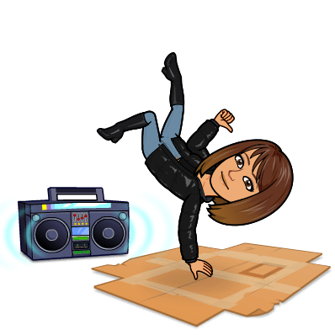
- Activity 1. Sing and dance! https://www.youtube.com/watch?v=ZbZSe6N_BXs

- Remember the new words!
Activity 2. Look, read and tick or cross.

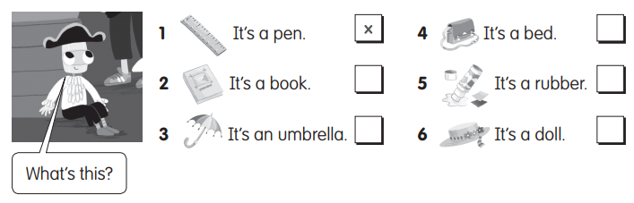

- Study these examples:

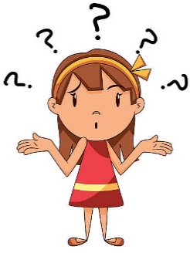

What’s this?
It’s an umbrella.

What’s this?
It’s a pencil.

What’s = What is
It’s = It is

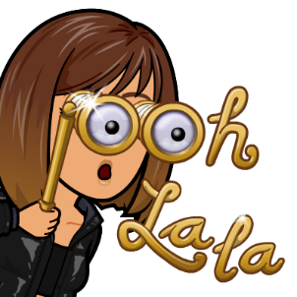
Watch these videos to reinforce the lesson:
- What’s this rap! https://www.youtube.com/watch?v=mTisVqSrfF0
- A or an? https://www.youtube.com/watch?v=B8MbH5Wwf5I

Time to practice!

Activity 1. Circle the first letter. Write a or an.

Activity 2. Follow the lines. Write the answers.
It’s a pencil. It´s a rubber. It’s an apple.

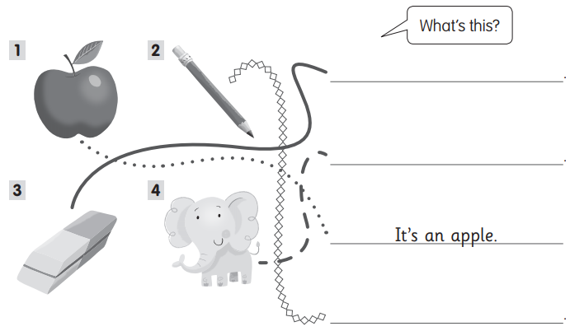

TEXT PRODUCTION CHECKLIST
Contextualized Achievement performance | Descriptors
 | A | B | C
Write answers using the grammar structure correctly.

ORAL PRODUCTION CHECKLIST
Contextualized Achievement performance | Descriptors
 | A | B | C
Interact with a partner asking and answering questions to identify objects in a short dialogue.

